Lab - Configuring Basic DHCPv4 on a Router

1. Topology

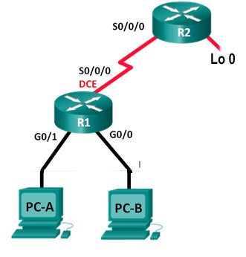

S0/1/1

S0/1/1

**DHCP SERVER**

**LAN 2**

**LAN 1**

1. Addressing Table

|  |  |  |  |  |
| --- | --- | --- | --- | --- |
| Device | Interface | IP Address | Subnet Mask | Default Gateway |
| R1 | G0/0/0 | 192.168.10.1 | 255.255.255.0 | N/A |
|  | G0/0/1 | 192.168.20.1 | 255.255.255.0 | N/A |
|  | S0/1/0 (DCE) | 192.168.2.1 | 255.255.255.0 | N/A |
| R2 | S0/1/0 | 192.168.2.2 | 255.255.255.0 | N/A |
|  | Lo 0 | 209.165.200.226 | 255.255.255.224 | N/A |
| PC-A | NIC | DHCP | DHCP | DHCP |
| PC-B | NIC | DHCP | DHCP | DHCP |

1. Objectives

Part 1: Build the Network and Configure Basic Device Settings

Part 2: Configure a DHCPv4 Server

1. Build the Network and Configure Basic Device Settings

In Part 1, you will set up the network topology and configure the routers and switches with basic settings, such as passwords and IP addresses. You will also configure the IP settings for the PCs in the topology.

* 1. Cable the network as shown in the topology.
  2. Configure basic settings for each router.
     1. Console into the router and enter global configuration mode.
     2. Configure the host name as shown in the topology.
     3. Configure the IPv4 addresses on the router as shown in the topology.

**Example**:

R1(config)# **int g0/0/0**

R1(config-int)# **ip address 192.168.10.1 255.255.255.0**

R1(config-int)# **no shut**

* 1. Configure dynamic, default, and static routing on the routers.
     1. Configure a default static route for R1.

R1(config)# **ip route 0.0.0.0 0.0.0.0 S0/1/0**

* + 1. Configure static routes route on R2.

R2(config)# **ip route 192.168.10.0. 255.255.255.0 S0/1/0**

R2(config)# **ip route 192.168.20.0. 255.255.255.0 S0/1/0**

1. Configure a DHCPv4 Server

To automatically assign address information on the network, you will configure R2 as a DHCPv4 server and R1 as a DHCP relay agent.

* 1. Setup Helper Addresses on R1

R1(config)# **interface G0/0/0**

R1(config-if)# **ip helper-address 192.168.2.2**

R1(config-if)# **exit**

R1(config-if)# **interface G0/0/1**

R1(config-if)# **ip helper-address 192.168.2.2**

* 1. Configure DHCPv4 server settings on router R2.

On R2, you will configure a DHCP address pool for each of the R1 LANs.

**Pool 1 For 192.168.10.0 Network**

Use the pool name **LAN1-POOL** for the G0/0/0 LAN. Exclude the first 9 addresses in each R1 LAN starting with .1. All other addresses should be available in the DHCP address pool. Make sure that each DHCP address pool includes a default gateway, the domain **ccna-lab.com**, a DNS server (209.165.200.225), and a lease time of 2 days.

R2(config)# **ip dhcp excluded-address 192.168.10.1 192.168.10.9**

R2(config)# **ip dhcp pool LAN1-POOL**

R2(dhcp-config)# **network 192.168.10.0 255.255.255.0**

R2(dhcp-config)# **default-router 192.168.10.1**

R2(dhcp-config)# **dns-server 209.165.200.225**

R2(dhcp-config)# **domain-name ccna-lab.com**

R2(dhcp-config)# **lease 2**

**Pool 2 For 192.168.20.0 Network**

Use the pool name **LAN2-POOL** for the G0/0/1 LAN. Exclude the first 9 addresses in each R1 LAN starting with .1. All other addresses should be available in the DHCP address pool. Make sure that each DHCP address pool includes a default gateway, the domain **ccna-lab.com**, a DNS server (209.165.200.225), and a lease time of 2 days.

R2(config)# **ip dhcp excluded-address 192.168.20.1 192.168.20.9**

R2(config)# **ip dhcp pool LAN2-POOL**

R2(dhcp-config)# **network 192.168.20.0 255.255.255.0**

R2(dhcp-config)# **default-router 192.168.20.1**

R2(dhcp-config)# **dns-server 209.165.200.225**

R2(dhcp-config)# **domain-name ccna-lab.com**

R2(dhcp-config)# **lease 2**

On PC-A or PC-B, open a command prompt and enter the **ipconfig /all** command. Did either of the host PCs receive an IP address from the DHCP server? Why? Yes it did

* 1. 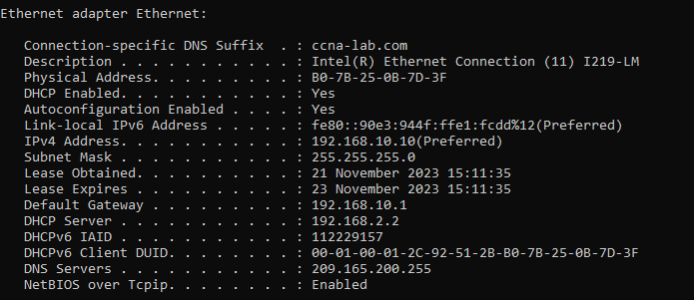Record IP settings for PC-A and PC-B.

On PC-A and PC-B, issue the **ipconfig /all** command to verify that the PCs have received IP address information from the DHCP server on R2. Record the IP and MAC address for each PC.

B0-7B-25-0B-7D-3F

192.168.10.10

Based on the DHCP pool that was configured on R2, what are the first available IP addresses that PC-A and PC-B can lease?

* 1. Verify DHCP services and address leases on R2.
     1. On R2, enter the **show ip dhcp binding** command to view DHCP address leases.

Along with the IP addresses that were leased, what other piece of useful client identification information is in the output?

* + 1. 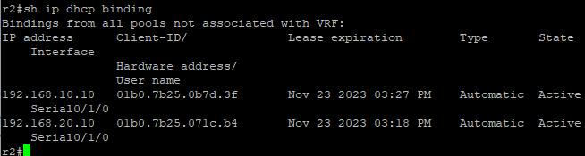

On R2, enter the **show ip dhcp server statistics** command to view the DHCP pool statistics and message activity.How many types of DHCP messages are listed in the output?

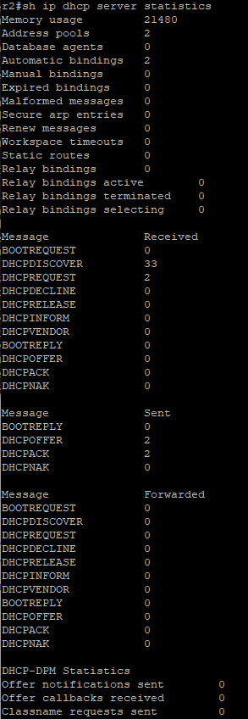

* + 1. On R2, enter the **show ip dhcp pool** command to view the DHCP pool settings.

In the output of the **show ip dhcp pool** command, what does the current index refer to?

It refers to the ip address range

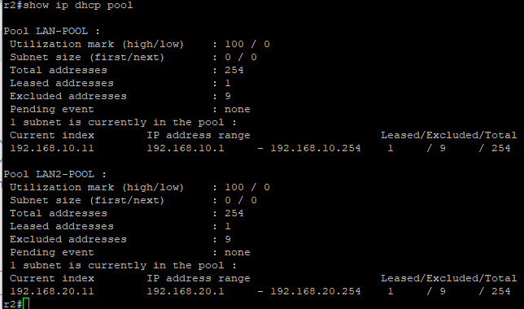

* 1. Viewing DHCP Operation.
     1. On PC-A, run Wireshark and start a capture
     2. Put **dhcp** in the filter window
     3. From the command prompt on PC-A type **ipconfig /release**.
     4. From the command prompt on PC-A type **ipconfig /renew**
     5. Stop the capture.
     6. Put a screen shot of the capture here:

